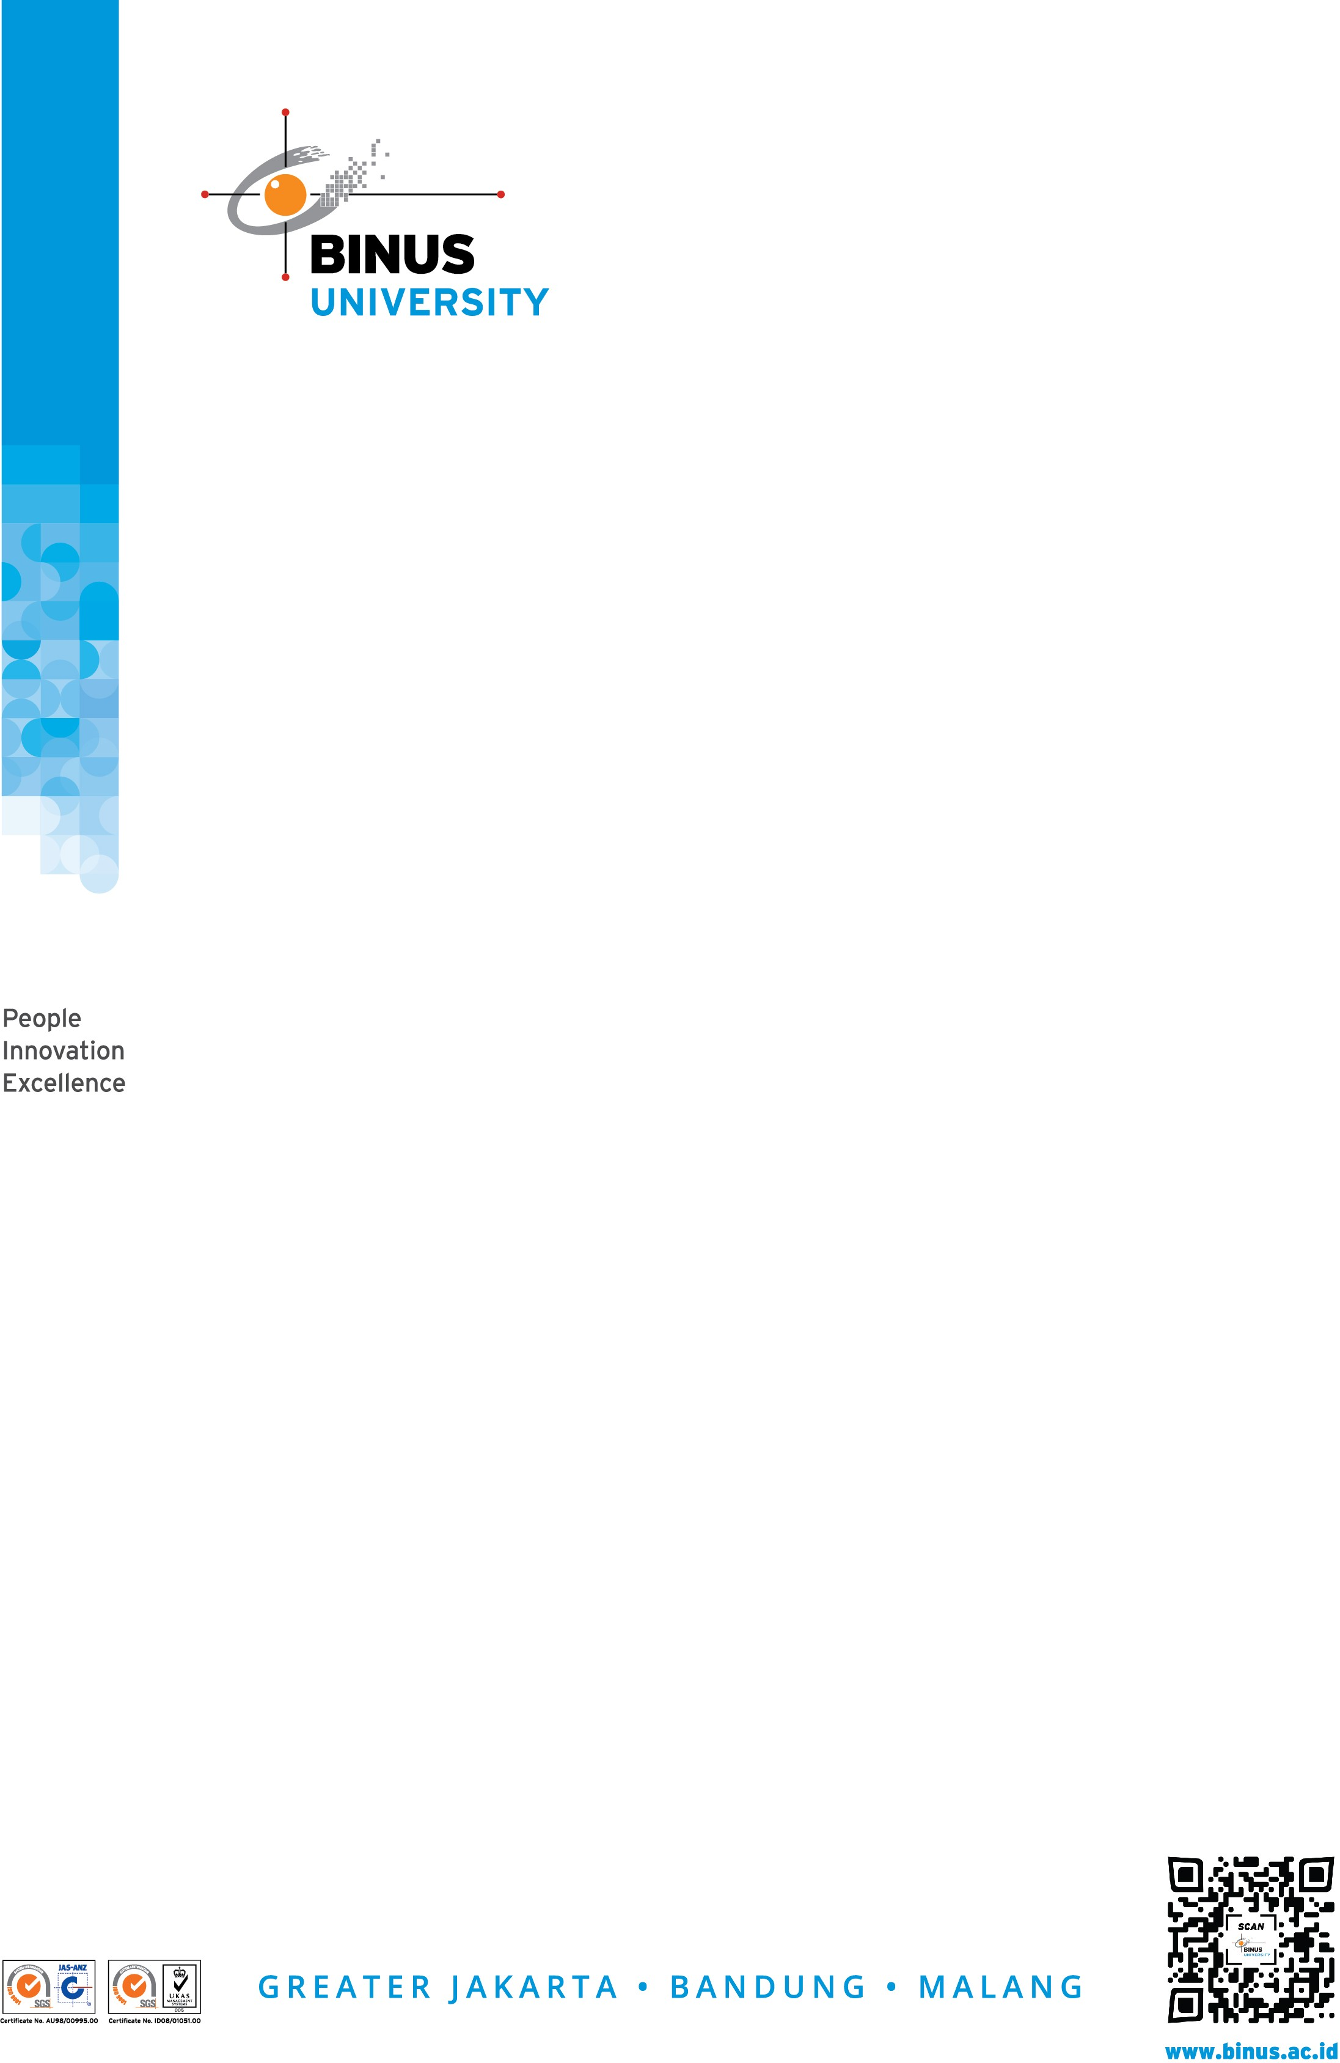

Industrial Visit Invitation

April 14, 2022

Invitation Letter for - **Software Laboratory Center Industrial Visit**

Dear Sir/ Madam,

Greetings from Software Laboratory Center. We would like to take a brief moment of your time to introduce us to you. Software Laboratory Center is a technical services unit at Bina Nusantara University. We provide software-based practical work for students. Our team consists of 150 staffs to guide the students and help the lecturers which we usually call as a Laboratory Assistant. Laboratory Assistants are Bina Nusantara University students who wants to get work experience while studying at college. Currently our team consist of the 2nd– 8th semester students and Bachelor/ Master Degree graduates.

# Previous Activity

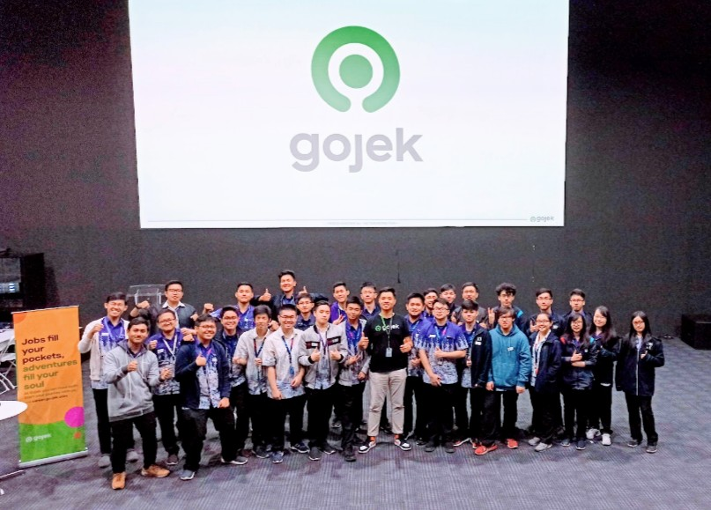

Gojek Industrial Visit – 2020

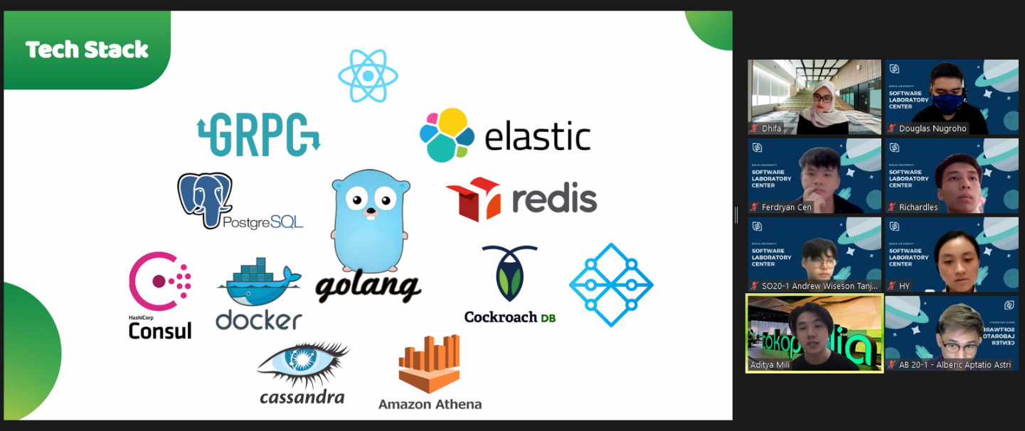

Tokopedia Industrial Visit -– 2021

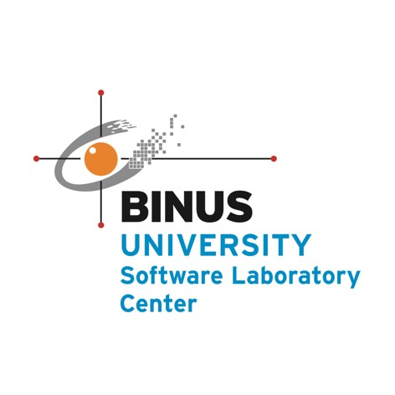

# Other Activities

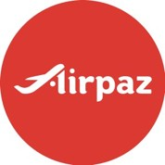Info Session from

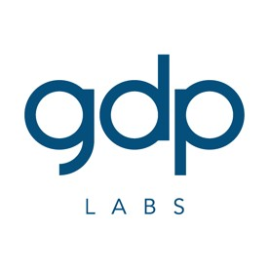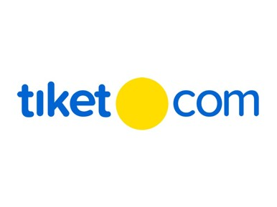



# Invitation

The industrial visit is conducted as our annual program. The primary objective of this visit is to get familiar with the industry, technology, working life, and the industry working procedure. Besides that, we also hope that our Laboratory Assistants may gain new knowledge from your company and even be inspired to join you as young talents after they graduate.

We as Quality Management and Collaboration Officers in Software Laboratory Center are planning to organize an industrial visit around the July 2nd –August 28th, 2022 and we are inviting a speaker from **Tiket.com** to Software Laboratory Center Industrial Visit. We hope to hear from you whether such coordination is possible. Looking forward to meet you soon.

Sincerely,

Orlando Keni Sentana

Collaboration Officer – Software Laboratory Center Phone: (021) 5345830 Ext. 1944

Email: [orlando.sentana@binus.edu](mailto:orlando.sentana@binus.edu)